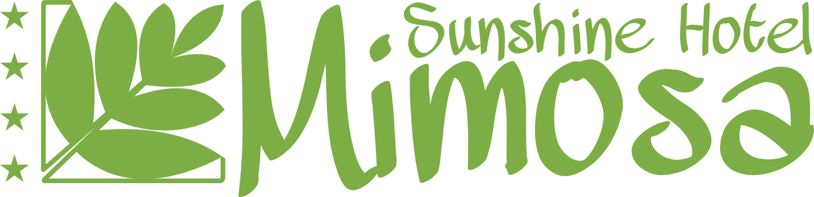
Mimosa Sunshine Hotel
ALL INCLUSIVE INFORMATION

BREAKFAST – 07.30 – 10.00 In Main restaurant
Buffet – standard buffet table, warm and cold dishes (bread, vegetables, sausages, French toast), broached non-alcoholic and warm beverages.

SNACKS – 10.00 – 16.00 In Bistro
Buffet – standard buffet table, sandwiches, pizza, desserts, broached non-alcoholic and local alcoholic drinks.

LUNCH – 12.30 – 14.30 In Main restaurant
Buffet – standard buffet table, warm and cold dishes, vegetables, soup, spaghetti, desserts, fruits, broached non-alcoholic and alcoholic beverages

DINNER – 18.00 – 21.00 In Main restaurant
Buffet – standard buffet table, varied international and Bulgarian kitchen, desserts, fruits, show- cooking, broached non-alcoholic and alcoholic beverages.

THEMATIC DINNER – 19.00 – 21:00 In Bulgarian restaurant
Traditional Bulgarian dishes
FREE SUNBEDS AND UMBRELLAS ON THE BEACH 250m.
DRINKS – 10.00 – 23.00 – Lobby Bar
NIGHT BAR – 19.00 – 23.00
POOL BAR - 11.00 – 18.00
ANIMATION – sport, evening show
KIDS CLUB – 4 – 12 years
Parking and deposit box against charge!

